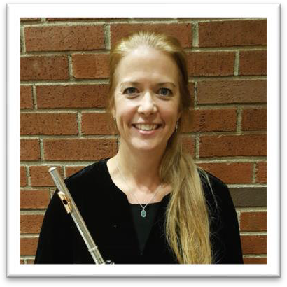
The Medina Community Band
Amy Muhl
Amy Muhl
Marcus L. Neiman, conductor
Dr. Darren LeBeau, associate conductor
Matthew Hastings, & Amy Muhl, assistant conductors

Summer Gazebo Concert – Friday, June 19th, 2026

Greetings & Welcome

Lu Ann Gresh, president – Medina Community Band Association

The Brass Band of the Western Reserve

Anthem, Star Spangled Banner (1889/1917) Francis Scott Key ^+
Arr. John Philip Sousa
Harmonized Walter Damrosch

Patriotic, American Pageant Thomas Knox
Gallehue

March, Liberty Bell John Philip Sousa
Keith Wilkinson
Medley, Manilow Magic Barry Manilow
Alan Fernie

Medley, Breezin’ Down Broadway arr. Goff Richards

Traditional, Just a Closer Walk With Thee arr. Geldard

Jazz, Puttin’ On the Ritz Irving Berlin
Stephen Roberts

March, Strike Up the Band Irving Berlin
Goff Richards
The Medina Community Band
Amy Muhl
Amy Muhl
Rhapsody, American Folk Rhapsody No 2 (1959) Clare Grundman *

March, Free Lance (1906) John Philip Sousa *

Dance, Seis Manuel (from “Islas y Montanas”) (2003) Karl Shelly Hanson +

Swing, Benny Goodman King of Swing Benny Goodman +
Paul Murtha

Screamer, Quality Plus (1913) Fred Jewell *

Combined, America, the Beautiful (1882/1963) Samuel Augustus Ward ^+
Carmen Dragon

March, Glory of the Yankee Navy (1909) John Philip Sousa +

March, Stars and Stripes Forever (1939) John Philip Sousa ^*

Patriotic, God Bless America (1900) Irving Berlin *
Erik W. G. Leidzén

Patriotic, Goin’ Home (from New World Symphony) (1896) Antonín Dvořák *
Jari A. Villanueva
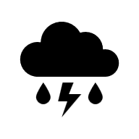
+ Dr. Darren LeBeau, conducting  * Marcus Neiman, conducting ^ Combined selections
No rain site for this concert Program subject to change

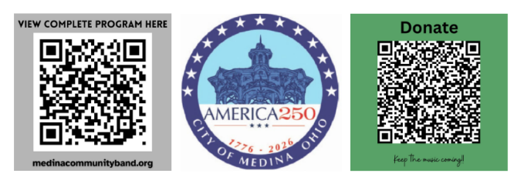

The Brass Band of the Western Reserve
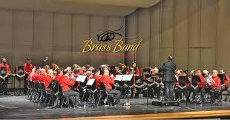
The Brass Band of the Western Reserve was founded in 1997 by Dr. Keith Wilkinson, a nationally renowned British brass band conductor, arranger and frequent adjudicator at the North American Brass Band Competition.

BBWR’s current director, Jay Wardeska, has been a band conductor and active trumpet player in the state of Ohio for more than 30 years. He currently serves as a Graduate Teaching Associate in music education at Ohio State University, where he’s pursuing a PhD in Music Education.

Wardeska has been the recipient of many honors and appointments, including being named the 2013 National Band Director of the Year by the National Association for Music Education and the U.S. Army Band.

The band follows British brass band instrumentation, using cornets and tenor horns in place of trumpets and French horns. Tubas, euphoniums, baritones and trombones round out the band, with a strong percussion ensemble for support.

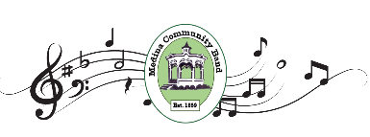

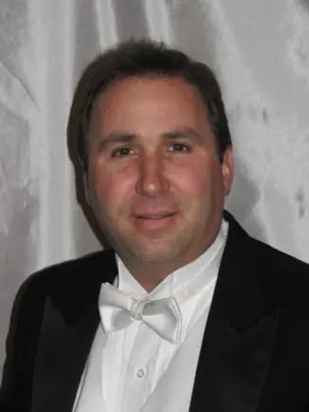
Jay Wardeska currently serves as the Executive Director of the Ohio Music Education Association (OMEA). In March of 2022, he was named the music director of the Brass Band of the Western Reserve. He is currently a PhD candidate in Music Education at The Ohio State University and holds a Master of Music in Instrumental Conducting from Kent State University and a Bachelor of Music Education from the University of Mount Union.

Wardeska taught music at the middle school, high school, and college levels in the State of Ohio for over 30 years. Bands under his direction performed at a number of state and national events including OMEA Professional Development Conferences, the Ohio Band Directors Conference, the NAfME-Disney Honors Festival, the U.S. Army Band President’s Concert, the University of Akron Concert Band Clinic, and partnership concerts with a number of university band programs.

Wardeska has been the recipient of many honors and appointments, including being named the 2013 National Band Director of the Year by the National Association for Music Education (NAfME) and the U.S. Army Band. Additional awards and appointments include the Joseph A. Leeder Award in Music Education, selection to the NAfME U.S. Army All-American Band Directors Academy, Grammy Quarterfinalist for the Music Educator of the Year, the Medina County Arts Council’s Service to the Arts Award, National Band Association Citation of Excellence, and the National Excellence in Teaching Award. He is also a Martha Holding Jennings Foundation Jennings Scholar. Other professional memberships include Phi Beta Mu and the American School Band Directors Association.

