Marcus L. Neiman, conductor
Dr. Darren LeBeau, associate conductor
Matthew Hastings, & Amy Muhl, assistant conductors

Summer Gazebo Concert – Friday, June 12th, 2026

Greetings & Welcome

Lu Ann Gresh, president – Medina Community Band Association
Medina County Historical Society – Social Hosts

Anthem, Star Spangled Banner (1889/1917) Francis Scott Key
Floyd Werle

Overture, Blue and The Gray (1961) Clare Grundman

March, Hosts of Freedom (1920) Karl L. King

Flute Trio, The Penny Whistle Song (1951) Leroy Anderson
Dr. Tracy Gulling-Leftwich, Sue McLaughlin, Amy Muhl, soloists

March, Semper Fidelis (1888) John Philip Sousa
Clarinet Duet, Concertpiece for Two Clarinets, No 2, Mvt 3 (1832) Mendelssohn
Harry Gee
Mary Ann Grof-Neiman and Erich Standar, soloists

March, March of the Women Marines (1943) Louis Saverino

For the Kids, Teddy Bear’s Picnic (1907) John C. Bratton
Patriotic, Duty, Honor, Country (1967) Harold Walters

Mark Phillips, guest speaker
Patriotic, Salute to the Armed Forces arranged by Jari Villanueva

March, Stars and Stripes Forever (1939) Irving Berlin

Patriotic, God Bless America (1900) John Philip Sousa
Erik W. G. Leidzén

Patriotic, Goin’ Home (from New World Symphony) (1896) Antonín Dvořák
Jari A. Villanueva
Program subject to change

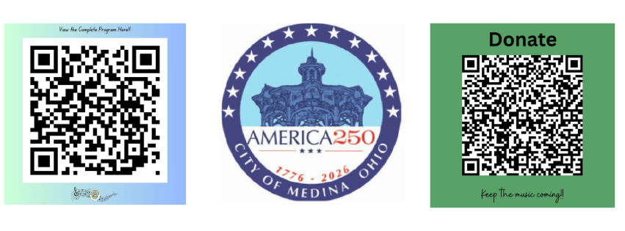

Featured Soloists & Speakers for June 12th, 2026

Mark Phillipp retired from the Marine Corps in 2021 and is currently a Veterans Service Officer at the Medina County Veterans Service Office. He lives in Medina Township with his wife and three children. (26 04 01)
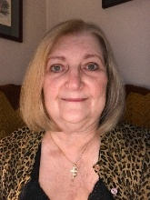
Mary Ann Grof-Neiman clarinet section leader and head librarian received her bachelor of science in music education degree from the Bowling Green State University. Ms. Grof-Neiman has served as principal clarinetist with the Sounds of Sousa Band and as clarinetist for the Blossom Festival Band, the Cleveland Winds, Lakeland Civic Band, Lakeside Symphony Orchestra, Youngstown Symphony, Chagrin Falls Studio Orchestra and Erie Philharmonic. She currently performs with the Cleveland Philharmonic Orchestra, Heights Chamber Orchestra, Home Town Concert Band, Akron Symphonic Winds and Medina Community Band. She maintains private studios at Baldwin Wallace College through their Community Arts School as well as her home in Medina. She has served the Ohio Music Education Association as a Woodwind Adjudicator for the last 36 years and most recently as clarinet auditioner for the All-State Band/Orchestra (2025 Cleveland Conference). She is currently a member of AFM Local 4. (as of 26 04 01)

Erich Standar, clarinet duet, has been a member of Medina Community Band since 2017. He graduated from Highland High School in the class of 2018, where he was a member of the school’s Marching Band, Wind Ensemble, and Jazz Band. He was a member of the Pit Orchestra (fall 2016 and 2017) musicals; Mary Poppins and Fiddler on the Roof. He brought back the school’s Clarinet Choir which he led during his senior year. Erich was the recipient of the John Philip Sousa Award (Spring 2018) for superior musicianship and outstanding education. Erich is the band’s Assistant Librarian. (24 04 10)
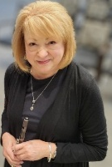

Dr. Tracy Gulling-Leftwich, DO, flute, is a Hospice and Palliative Medicine physician. She earned her BS in biology and music with emphasis on flute under the direction of David P. Tessmer from Westminster College, New Wilmington, PA in 2003. She participated in Flute Choir, Wind Ensemble, Marching and Concert Band. She completed her Doctor of Osteopathic Medicine at Lake Erie College of Osteopathic Medicine in 2007 and her Internal Medicine residency at University of Connecticut in 2010. She returned to Ohio in 2014 to be closer to family and joined the Medina Community Band shortly thereafter. She resides in Bay Village with her husband, Sam; son, Arthur; and their puggle, Boomer. (25 05 26)
Sue McLaughlin, flute, has been a flute player with the Medina Community Band since 1994. In addition to performing on flute and piccolo with the band, she has played with Marcus Neiman and The Sounds of Sousa Band, Symphony West Orchestra, Medina Show Biz, Champagne Flutes, and the Supertonics Flute Ensemble, as well as with various church and community groups. Sue currently serves as the flute section leader, the media and public relations contact for the band, and the secretary of the Medina Community Band Association. She lives in Medina with her two cats, Archie and Lilibet, and has a daughter and two grandsons. (26 05 25)
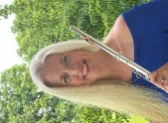
Amy Muhl, flute, has been a member of Medina Community Band since 1998. Originally from Lyme, Connecticut, moved to Ohio to study music education at Oberlin Conservatory in 1991. She graduated in 1995 and taught orchestra for two years in the Willard City Schools. Amy received her Master of Music Education from Kent State University on a scholarship, in 1998. She then taught instrumental music at Buckeye High School, in Medina (OH) and in the fall of 1999, became the elementary band teacher for Buckeye Local Schools. In the fall of 2001, she began teaching elementary instrumental music at Central Intermediate School in the Wadsworth City Schools. After raising Eva and Simon for 5 years, Amy returned to Wadsworth Schools teaching general music at Valley View Elementary and is now back at Central Intermediate School teaching general music and choir. Amy also plays flute/piccolo and piano, in addition to being a member of Medina Community Band and Sounds of Sousa Band. She is also Vice President of the Medina Community Band Association. Amy resides in Wadsworth with her husband Frank, and three children, Kenneth, Eva and Simon. (25 05 24)

