Medina Community Band
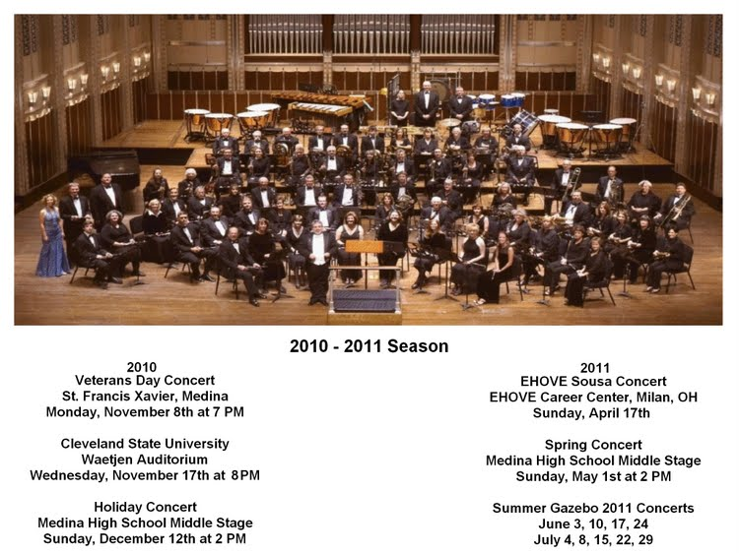

Banding together to celebrate a new land. The Medina Community Band traces its beginnings back to 1859, when a group of local wind and percussion players got together (some with formal training - others without) to perform music for the community. That first "community band" was called The Medina Silver Cornet Band, probably since the instruments the musicians used were primarily "silver lacquer coated" cornets or percussion. Since it’s beginning in 1859, that the band has been in existence, there have been 20 directors. Marcus Neiman has served as conductor since 1972 with John Connors serving as assistant conductor (since 2015).
Early versions of the band probably existed at the pleasure of the square's business community, who often funded the season and encouraged patrons to attend the concerts. The performance night has changed over the years, in most cases at the urging of the business community, and season concerts have been given on Sunday, Monday, Tuesday, Thursday, Friday, and Saturday evenings. Since the 1970s, the band has been supported by donations from the general public and, to this day, is supported through these donations. Band members donate their time and talent to rehearsing and performing for the community as members of the ensemble.
Since the 1970s, Medina Community Band has traveled outside Medina to perform: Ashland Brookside Bandstand (1980, 81, 93); Bay Village (Connections Series 1990, 91, 92); Canton (Kent State Stark Community Band Exchange Concerts 1995, 96, 98, 99); Case Western Reserve University (Cleveland Youth Winds Exchange concerts – Severance Hall – 2002 and 2007, Medina, 2005); Cleveland State University (2010, 13); Dalton (Wayne County Schools Honors Bands 1983); Mentor (Lakeland Civic Band Festival 1985 and 1990); Mercer (PA) (with Mercer Community Band, 2009); Milan (EHOVE Career Center, yearly since 1993); and, Wadsworth (Wadsworth Community Band Festival 2007). In February of 2015, Medina Community Band was selected by blind audition to perform at the Ohio Music Education Association Professional Development Conference in Cleveland.
Regional and nationally known conductors have appeared with Medina Community Band. Since the 1970, the following individuals have appeared as guest conductors: David Adamson; William Bauer (Florida State University); Frank Cosenza (Mentor, OH); Albert Oliver Davis; Paul Droste (Ohio State University), John Boyd (Indiana State University); Wayne Gorder (Kent State University); John Franklin (Kent State University); Patricia Ann Grutzmacher (Kent State University); Richard Jackoboice (University of Akron); Robert Jorgensen (University of Akron); Galen Karriker (University of Akron); Jesse Leyva (Kent State University); Gene Milford (University of Akron); Nathan Muehl (St. Petersburg College, Florida); Bill Park (North Royalton Community Band); David Seiberling (Moore Community Band); Edmund J. Siennicki; and, Nathan Stark (Montana State University).
The following individuals have been commissioned, or have written, or arranged, works for Medina Community Band: Douglas Court; Albert Oliver Davis; Robert Feldbush; Percy Hall; Floyd O. Harris; Stuart Ling; Gene Milford; Bill Park; Tadd Russo; David Schaffer; David Seiberling; Edmund J. Siennicki; Gail Sigmund; and, Jonathan Tietz.
Medina Community Band is sponsored by the Medina Community Band Association composed of members of The Medina Community Band proudly supports the community band. Membership in Medina Community Band is open and there are no dues or auditions; however, members are expected to maintain a regular attendance. The band rehearses in the band room at Highland Middle School (3880 Ridge Road, Medina) on Wednesday evening from 7p until 9p September through the end of May; providing three to four concerts during the fall, winter, and spring months both at home and on the road, as well as every Friday evening June through July in the Gazebo in Medina’s Uptown Park Square and a special concert on July 4th.

